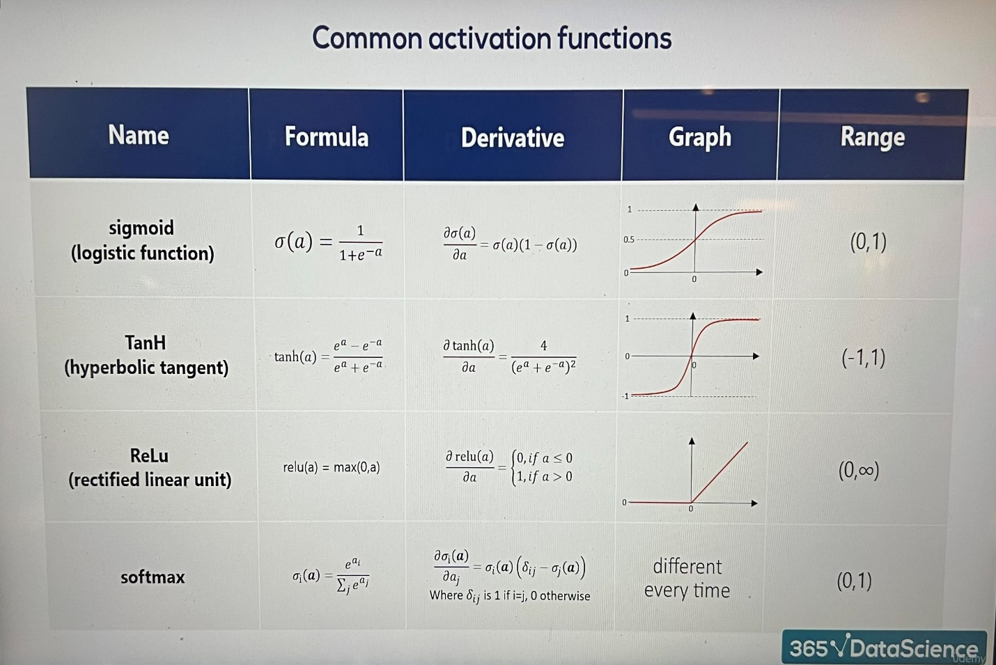

# The Softmax Activation Function

**1. Why Softmax is Different**

* Most activation functions (sigmoid, ReLU, tanh) take **one input number** and transform it independently.
* **Softmax is different**:
  + It takes the **entire vector** of values at once.
  + Each output depends on **all inputs together**.

2. The Formula

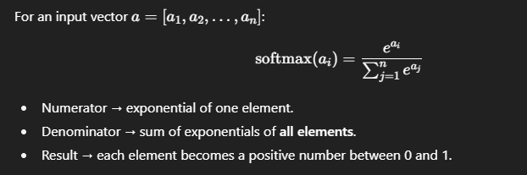

**3. Example Walkthrough**

Suppose we have a hidden layer with 3 units, producing:

$$a=[-0.21, 0.47, 1.72]$$

1. Compute exponentials:
$e^{-0.21}≈0.81$

$e^{0.47}≈1.60$

$e^{1.72}≈5.58$

2. Denominator (sum):
$$0.81+1.60+5.58≈8.0$$

3. Divide each exponential by 8:

$0.81/8≈0.1$

$1.60/8≈0.2$

$5.58/8≈0.7$

Final softmax output:

$$[0.1, 0.2, 0.7]$$

**4. Why This Matters**

* Notice the properties:
  + All outputs are **between 0 and 1**.
  + They **sum to exactly 1**.
* That means the outputs form a **probability distribution**.

**5. Intuition in Practice**

* Let’s say we’re classifying an image among **3 classes**: Cat, Dog, Horse.
* The raw outputs (called **logits**) could be any numbers, like $[-0.21,0.47,1.72]$.
* After softmax → we get $[0.1,0.2,0.7]$.
* This means:
  + 10% chance it’s a Cat
  + 20% chance it’s a Dog
  + 70% chance it’s a Horse

👉 That’s why softmax is almost always used in the **final layer of classification networks**.

**✅ Key Takeaway**

Softmax takes messy raw outputs (logits) and converts them into a **clean probability distribution** over possible classes, making the model’s predictions **interpretable and useful**.